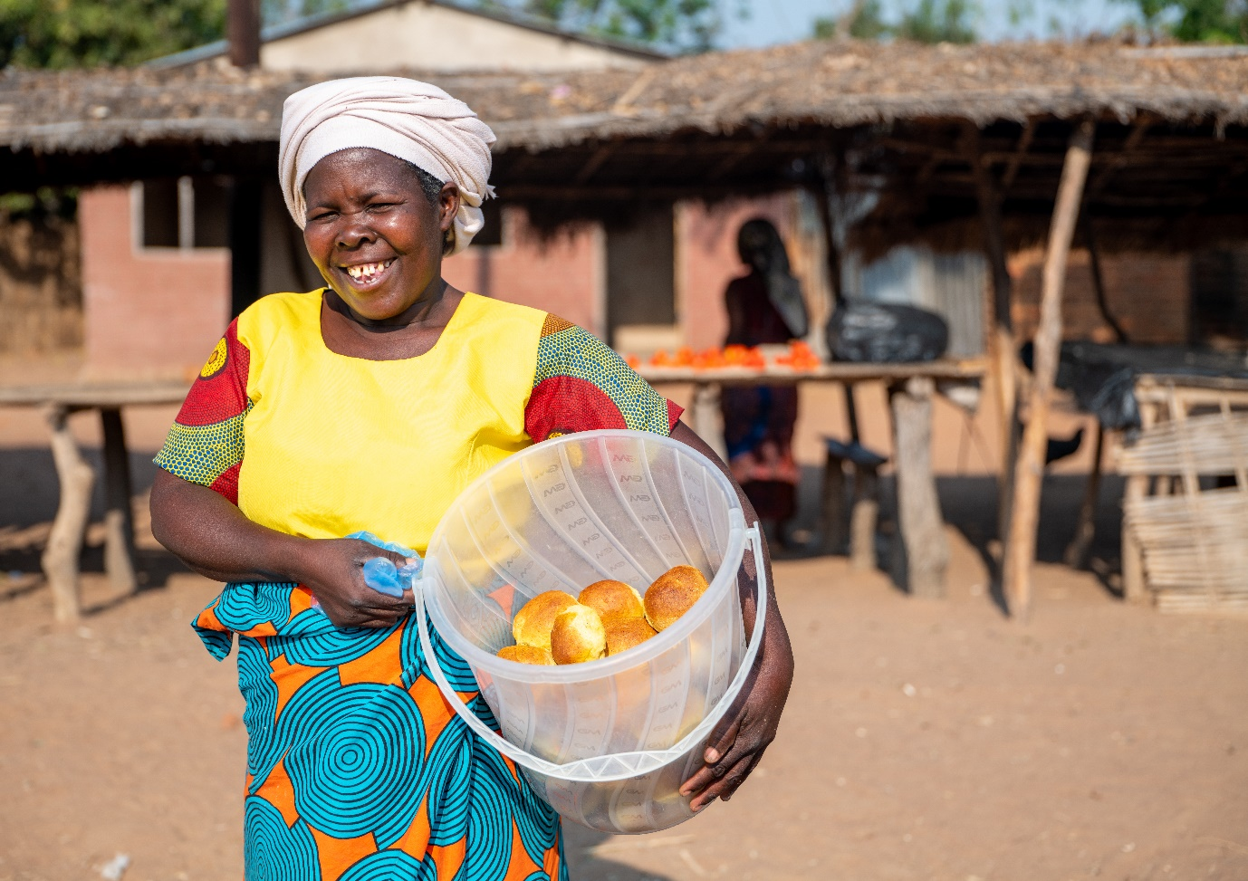
Caption: Esther Saizi and her cooperative make bread from processed pigeon peas. They meet every morning in the warehouse Christian Aid has built and use the large oven to bake bread to sell at the market.
Credit: Christian Aid/Adam Haggerty

Instructions for press release

Thank you very much for using one of our press releases.

Each Christian Aid Week supporters are responsible for a huge percentage of the local media coverage we receive. Sending a press release to your local press supports us by championing Christian Aid and raising awareness of our work around the world. It’s also a great catalyst for your own fundraising and a way to celebrate achievements locally.

In the press release below, you will need to change the parts in red and use the editable fields to tell your unique story. A picture and a quote accompanying your press release will really enhance the piece and get media attention.

If you need further support, get in touch with our friendly local supporter engagement teams at England: hello@christian-aid.org, Wales: wales@christianaid.org, Scotland: Edinburgh@christian-aid.org or telephone 01925 537 769. Alternatively contact or Juliet Lunam (regional media advisor) at JLunam@christian-aid.org.

NEWS RELEASE

People in (INSERT TOWN) are planning to take on The Big Pea Challenge to help communities in Malawi.

(INSERT NAME OF PERSON/GROUP) will be (INSERT ACTIVITY) to raise funds and help farmers in Malawi during Christian Aid Week 2023.
(INSERT PERSON’S NAME OR USE ‘The group/club/congregation’) will join hundreds of activists taking on The Big Pea Challenge as part of this year’s appeal. The focus for 2023 is on communities which are paying a harsh price for the global cost of living and climate crises.
Farmers in Malawi struggle to get a fair price for their goods and have been battling climate change, with rising temperatures and regular floods making it tough to grow crops.
But one plant is hardier than the others: the pigeon pea is a small but mighty seed which is drought resistant, soil-revitalising and high-protein. And it has inspired Christian Aid supporters in the UK and Ireland to think of veggie-themed fundraisers, so more can be done to make the most of the product.
They have been tasked to come up with any kind of challenge they want – as long as it features peas.
(INSERT NAME AND TITLE OF SPOKESPERSON) said: “The Big Pea Challenge is all about coming together in fun and friendship to help bring real change to our global neighbours.
“(PLEASE USE THIS LINE TO EXPLAIN WHY YOU CHOSE YOUR PARTICULAR CHALLENGE…EG We decided to hold a community pea soup lunch so everyone could be involved).
“People the world over are struggling with the cost of living and having to make tough decisions.
“We are standing with those hardest hit by the climate crisis and the cost of living - people who are doing all they can to break free from poverty and fulfil ambitions of going to college and building thriving businesses.
“As supporters of Christian Aid, we are united in hope for a brighter future. It is possible to change things and with people’s help this Christian Aid week, we can make dreams come true.”
The money raised during Christian Aid Week will help the charity’s partner agencies in Malawi with projects to combat the effects of climate change on crops and ensure farmers are paid a fair price for their produce. The aim is to help people find practical and sustainable ways out of poverty, including gaining the skills to grow more resilient crops, restore soil fertility, increase harvests and to join cooperatives to earn more for their crops.
To support (INSERT NAME OF GROUP) during the Big Pea Challenge, visit: (INSERT BIG PEA CHALLENGE GIVING PAGE LINK)
ENDS
Notes to editors:

Case study –
Christian Aid’s two partners in Malawi are the Nandolo Farmers’ Association (NFA) and Alliance Development African Foundation (ADAF). NFA helps farmers market their produce, form co-operatives and supports them to increase their pigeon pea harvests. ADAF helps farmers who cannot obtain traditional bank loans with access to loans, and brings people together in village savings and loan associations.
One of the people these organisations have helped is Esther Saizi. The 54-year-old grandmother grows pigeon peas, which she uses to bake bread and also sells, using some of the profits to help her daughters with nursing training and a carpentry business, as well as paying for grandchildren to attend nursery.
Esther has struggled to get a fair price for her produce and lost a lot of her crops during Tropical Storm Ana. She felt desperate. But when she joined a pigeon pea programme run by Nandolo Farmers’ Association, and started selling as part of a co-operative, she was able to earn much more.
With the profits, Esther bought goats which also provide manure for her crops, saving on expensive fertiliser. She now keeps her peas in a warehouse, safe from floods and storms. She also processes pigeon peas into fish food using the co-operative’s machine, which was provided by Christian Aid.
“We are a community that helps one another a lot,” Esther said says. “If people face a problem, we do not allow them to suffer alone.”
This is how the money raised during Christian Aid Week can help:
- £50 could provide pigeon pea seeds and farming tools for a family.
- £70 could buy a bicycle so an experienced farmer can reach others in remote areas and teach them essential business skills.
  - £250 could pay for a cooperative oven, supporting more than 800 people to turn their pigeon peas into profit by baking bread.
- £1,000 could pay for a fish food processor, so co-operatives can turn their pigeon peas into fish food and raise fish to sell.

Christian Aid works in some of the world's poorest communities. We act where there is great need, regardless of religion, supporting people to live a full life, free from poverty. For more about Christian Aid’s work, visit www.christianaid.org.uk.
For more information contact:
(INSERT NAME OF LOCAL CONTACT) or Juliet Lunam (regional media advisor) at JLunam@christian-aid.org.

